# Lesson 6 单词讲解

1. beggar n. 乞丐

beg v. 乞讨；乞求，恳求

beg for food beg for help

I beg your pardon? = Pardon?

1. pocket n. 衣服口袋

pocket money 零花钱

1. call v. 拜访，光顾

call on sb. / call at sp.

He calls on his grandfather every week. The train called at Oxford just now.

visit sb. / sp.

冠词的作用

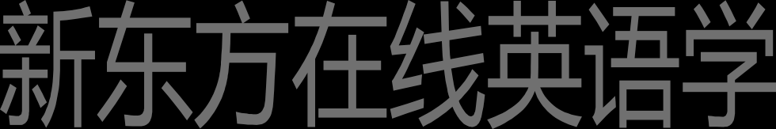定冠词 the 不定冠词 a / an 零冠词

# Lesson 6 课文&语法讲解

冠词的作用

# Lesson 8 课文&语法讲解

定冠词 the 表示特制

不定冠词 a / an 表示泛指

零冠词 不加冠词 表示特殊用途

打球吃饭 不加the

泛指 特指

不明确的对象 明确的对象

I am hungry. I want the apple in your I want an apple. hand.

首次提到的对象 再次提到的对象

I saw a dog in Bridge Street yesterday. The dog was really cute.

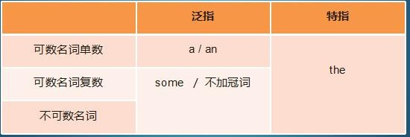

air pollution is a serious problem.

The air pollution of Beijing must be solved at once.

Lisa gave me some tea as a gift. Some也可以不填

The tea tasted good.

Last month I bought a CD. The CD is about the Civil War, and I found

The CD very interesting.

I enjoy reading. Although books are expensive, I always buy

books in the bookstore in London Street.

1.I have just moved to a house in Bridge Street. 2.Yesterday a beggar knocked at my door.

1. He asked me for a meal and a glass of beer.
2. In return for this, the beggar stood on his head and sang songs.
3. I gave him a meal.
4. He ate thefood and drank the beer.
5. Then he put a piece of cheese in his pocket and went away. 8.Later a neighbour told me about him.

9.Everybody knows him. 10.His name is Percy Buttons.

11.He calls at every house in the street once a month and always asks for a meal and a glass of beer.

# Lesson 6 知识拓展

本课重点:

冠词

a / an / the

冠词

As everyone knows, children require a lot of time and attention.

A: Frank, where are children? B: Next door at the Jacksons’.

冠词

water is essential to human life,

but don’t drink water in the Flat River.

It’ll kill you! pollution in that river is terrible.

冠词

Yesterday I saw dog and cat.

dog was chasing cat.

cat was chasing mouse.

mouse ran into hole, but hole was very small.

冠词

The mouse ran into a hole, but the hole was very small.

cat couldn’t get into hole, so it ran up tree.

dog tried to climb tree, too, but it couldn’t.

